**D15B/34 Mikil Lalwani CNS Experiment 1**

**Aim:**

To understand the process of Breaking the Mono-alphabetic Substitution Cipher using

Frequency analysis method.

**Theory:**

A mono-alphabetic cipher is a substitution cipher where each letter of the plain text is replaced with another letter of the alphabet. It uses a fixed key which consists of the 26 letters of a “shuffled alphabet”. Spaces and punctuation are left as it is.

**Algorithm-**

1. We first count the number of letters in cipher text and find the frequency of each letter.
2. Then we compare the frequency of letters of cipher text and plain text.
3. We then substitute the letters of cipher text which have the same frequency as plain text.

**Output -**

The following chart shows the frequency of each letter of the alphabet for the English language.

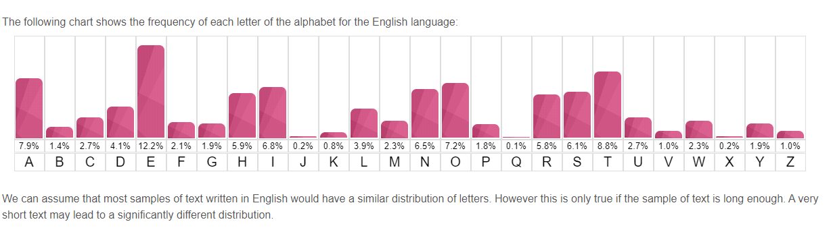

Cipher Text 1-

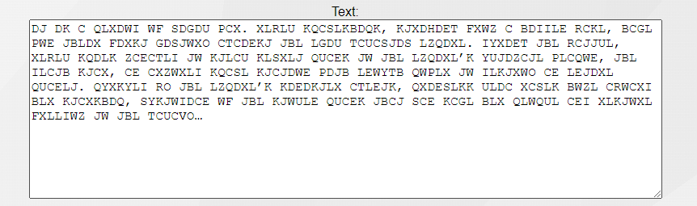

Deciphered text-

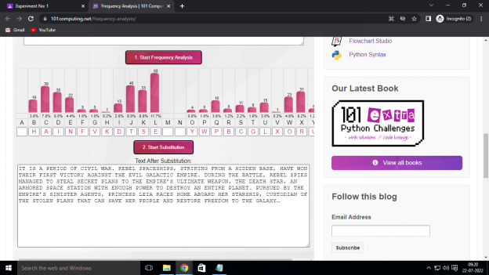

Cipher Text 2-

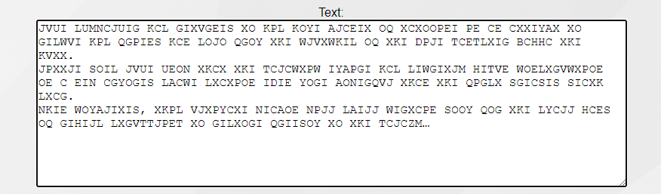

Deciphered text-

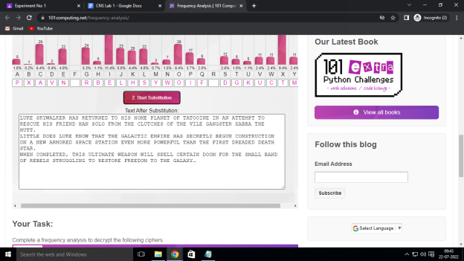

Cipher text 3-

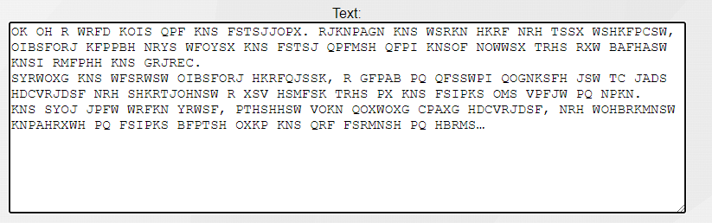

Deciphered text-

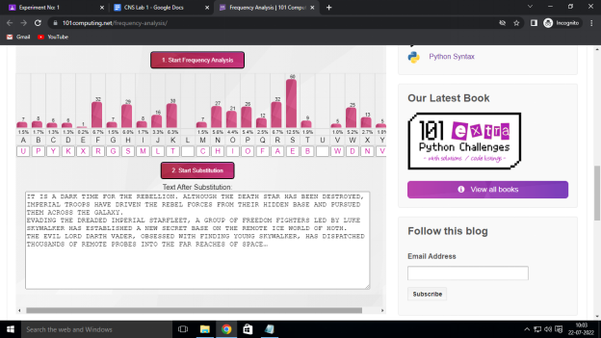

**Conclusion-**

Thus we have successfully deciphered text which was ciphered using mono-alphabetic substitution.